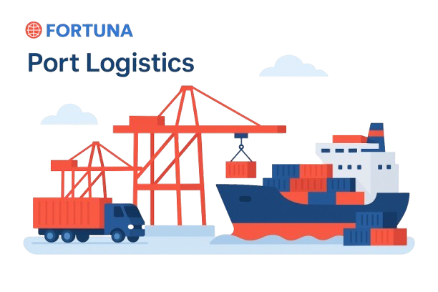



Website: www.fortunaglobalsupplychain.com
E-mail: info@fortunaglobalsupplychain.com

🏢 Company Overview

Fortuna Global Supply Chain Systems is a next-generation enterprise technology company revolutionizing the global logistics and supply chain landscape.
With a vision to create intelligent, transparent, and connected ecosystems, Fortuna blends innovation, data intelligence, and automation to help businesses achieve supply chain excellence.
Established with the belief that efficiency is the new currency, Fortuna empowers organizations to manage operations smarter — from demand planning to last-mile delivery — through real-time insights and seamless digital integration.
We are not just a technology provider; we are partners in transformation — driving global supply chain optimization with precision, performance, and predictive intelligence.

FORTUNA GLOBAL SUPPLY CHAIN SYSTEMS

“The Future of Enterprise Intelligence.”

Fortuna Plan Co-Pilot – “AI-Powered Sales & Operations Planning”

Fortuna Plan Co-Pilot is an AI-driven planning intelligence assistant built to synchronize supply, demand, and logistics across the enterprise.
It empowers organizations to make faster, data-driven, and reliable planning decisions by integrating predictive analytics, scenario simulations, and real-time collaboration within a unified platform.
By acting as a digital S&OP copilot, Plan Co-pilot continuously learns from data, anticipates business risks, and provides actionable recommendations to achieve end-to-end operational harmony — from forecasting to execution.
“Fortuna Plan Co-pilot transforms planning from reactive to proactive — ensuring every decision is connected, intelligent, and executable.”

Enterprises today face growing volatility in demand, supply, and logistics networks. Traditional S&OP processes often fail to respond swiftly to changing market signals.
- AI-powered scenario modeling for rapid what-if planning
- Real-time alignment across sales, operations, finance, and logistics
- Collaborative workflows to ensure consensus and accountability
- Predictive learning engines that improve accuracy over time

⚙️ 2. System Architecture
Fortuna Plan Co-pilot operates within the Fortuna Intelligent Planning Cloud, built around four core layers:
1️⃣ Integration Layer - Real-time data sync with ERP, CRM, DemandSense, SIMS, and TMS.
2️⃣ Cloud Infrastructure Layer – Secure SaaS framework hosted on AWS / Azure for global scalability.
3️⃣ AI Intelligence Layer – Predictive forecasting, scenario optimization, and risk analysis.
4️⃣ Visualization & Collabration Layer – Interactive dashboards, workflow automation, and AI Co-pilot interface.
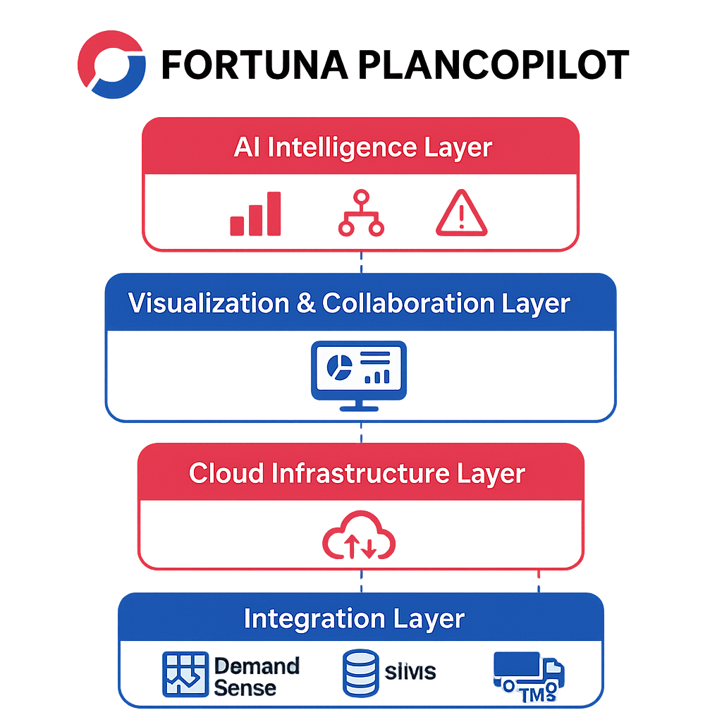

📊 1: Demand & Supply Alignment Engine

Product Modules, Sub-Modules & Operational Functionality

📚 Submodules:
- Unified Data Repository – Integrates forecasts, orders, production, and logistics data.
- Cross-Functional Consensus Planning – Sales, supply, and finance collaborate in one view.
- AI Forecast Integration – Imports predictive models from Fortuna DemandSense.
- Gap & Variance Analyzer – Detects plan mismatches across departments.

⚙️ Operational Functionality:
- Aggregates and harmonizes enterprise-wide data.
- Enables consensus-based decision-making with automated alerts.
- Balances supply capacity against forecasted demand dynamically.
- Visual variance reports for management and planning teams.

Product Modules, Sub-Modules & Operational Functionality

📚 Submodules:
- Historical Data Modelling – Learns from past sales, promotions, and seasonal behaviour.
- AI Forecast Generator – Produces short-term, mid-term, and long-term forecasts.
- External Signal Integration – Considers weather, events, and market indexes.
- Forecast Accuracy Tracker – Monitors prediction reliability using MAPE & RMSE.

⚙️ Operational Functionality:
- Automatically collects and cleans data from ERP/POS systems.
- Generates rolling forecasts updated daily or weekly.
- Uses deep learning algorithms to detect new demand trends.
- Provides scenario simulations (“what-if” analysis).

📊 2: Scenario Simulation & Optimization

📚 Submodules:
- What-If Simulation Engine – Models scenarios for demand surges, capacity shifts, or delays.
- AI Constraint Solver – Accounts for production limits, labor, and logistics dependencies.
- Profitability Impact Analyzer – Quantifies financial implications of plan alternatives.
- Risk & Resilience Planner – Provides backup options and response strategies.

⚙️ Operational Functionality:
- AI simulates and ranks best-fit scenarios within seconds.
- Provides actionable insights on service levels, cost impact, and fulfilment capacity.
- Enables leadership teams to approve optimal plans with data transparency.

💰 3: Finance & Budget Synchronization

📚 Submodules:
- Operational-Financial Alignment – Connects S&OP outputs to P&L projections.
- Revenue & Cost Balancing Engine – Evaluates revenue vs. capacity trade-offs.
- Margin & ROI Tracker – Monitors profitability across plan variants.
- Budget Forecast Simulator – Real-time budget projection based on plan changes.

⚙️ Operational Functionality:
- Synchronizes planning decisions with financial outcomes.
- Ensures production and procurement align with profitability targets.
- Provides cost sensitivity analysis to avoid budget overruns.
- Generates rolling financial forecasts linked to operational plans.

✅ 4: Collaboration & Governance Hub

📚 Submodules:
- AI Meeting Copilot – Summarizes discussions and action items automatically.
- Approval Workflow Engine – Defines authority levels and plan validation steps.
- Decision Traceability Log – Records rationale for each planning decision.
- Task & Responsibility Dashboard – Assigns accountability across departments.

⚙️ Operational Functionality:
- Converts planning sessions into actionable workflows.
- Provides instant summaries for leadership teams.
- Maintains a clear audit trail for compliance and transparency.
- Enhances speed of decision-making through structured governance.

🚚 5: Logistics Orchestration & S&OE Bridge

📚 Submodules:
- Logistics Feasibility Checker – Validates transport and yard availability before plan freeze.
- AI Capacity Matcher – Aligns logistics resources with supply schedules.
- Dynamic Rescheduling Engine – Adjusts short-term plans based on transport data.
- Execution Bridge (S&OE) – Links planning to day-to-day operational execution.

⚙️ Operational Functionality:
- Synchronizes logistics with production and demand forecasts.
- Predicts bottlenecks using live feeds from Fortuna TMS, YardSync, and LastMile AI.
- Suggests route or slot adjustments proactively.
- Bridges S&OP (strategic) and S&OE (execution) horizons seamlessly.

📈 6: AI Insights & Continuous Learning

📚 Submodules:
- Forecast Accuracy Dashboard – Tracks plan performance vs actual results.
- Learning Loop Engine – Auto-improves forecasting models using feedback.
- Executive BI Dashboard – Real-time KPIs and trends visualization.
- Planning Health Index – Measures planning process maturity and efficiency.

⚙️ Operational Functionality:
- AI identifies recurring inefficiencies and root causes.
- Continuously refines predictive algorithms for better future accuracy.
- Provides executives with visual insights and improvement areas.
- Enables adaptive learning cycles for sustained optimization.

🔗 7: Integration & Automation Layer

📚 Submodules:
- API Connectors – Integrates ERP, CRM, TMS, DemandSense, SIMS, and ConnectHub.
- Data Governance Framework – Ensures clean, verified, and auditable data flow.
- Workflow Automation Bots – Automates repetitive approval and data entry tasks.
- Security & Compliance Engine – Role-based access and audit control.

⚙️ Operational Functionality:
- Enables two-way data synchronization across systems.
- Reduces manual effort through event-triggered automation.
- Protects sensitive business data with enterprise-grade encryption.
- Supports both cloud and hybrid IT environments.

📊 8: Data Foundation & Quality Management

📚 Submodules:
- Data Integrity Scanner – Detects missing or inconsistent master data.
- Anomaly Detection Engine – Flags abnormal patterns in planning data.
- Master Data Control Hub – Centralizes key SKU, BOM, and location data.
- Data Freshness Monitor – Ensures all data inputs are current and accurate.

⚙️ Operational Functionality:
- Ensures accuracy of every planning decision.
- Prevents forecast and capacity errors caused by outdated data.
- Enhances trust and transparency across enterprise systems.
- Strengthens overall reliability of AI-driven insights.

📈 Functional Workflows

A. S&OP Planning Cycle
- Data Collection & Aggregation (ERP, CRM, DemandSense, SIMS) →
- AI Forecast & Alignment →
- Scenario Simulation →
- Consensus Planning →
- Financial Integration →
- Logistics Feasibility Check →
- Final Plan Approval & Execution

B. Adaptive Planning Workflow
- Real-Time Event Trigger (Supply / Demand / Logistics) →
- AI Suggests Revised Plan →
- User Approval via Co-pilot Interface →
- Auto-Sync with Execution Systems →
- Continuous Learning Feedback Loop

Fortuna Co-Pilot Advantages
Feature | Business Value
AI Powered Planning Assistant | Faster & More Reliable decision making.
Unified Data Modelling | True end-to-end alignment across Supply, demand & Planning
Scenario Simulation | Risk free, Predictive Planning
Financial & Logistics Sync | Seamless integration between strategy & execution.
Continuous AI Learning | Self-Improving intelligence engine
Cloud Collaboration | Real Time Planning Anywhere, Securely

Automotive & Industrial Manufacturing

🏭 Industries Served

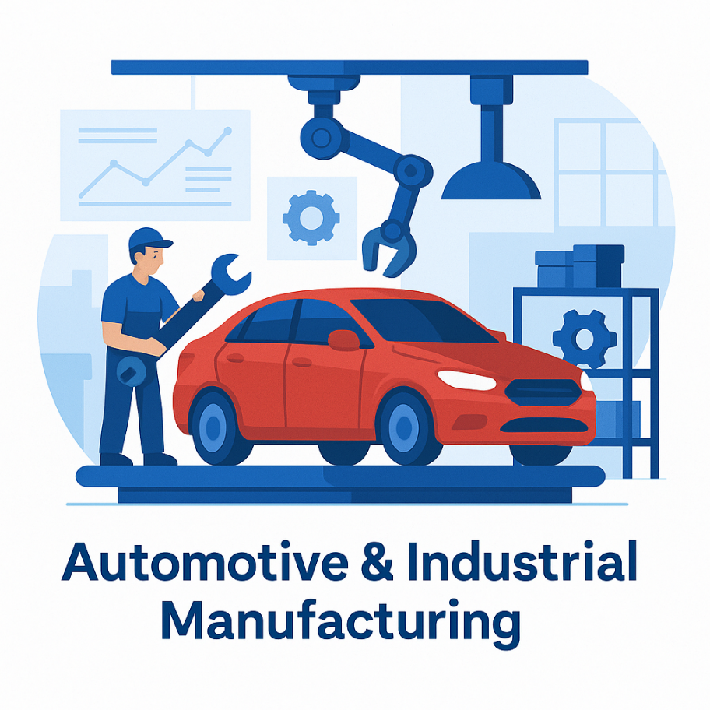
FGSCM - supports the automotive sector with advanced logistics planning, vendor coordination, and predictive maintenance scheduling. From global parts movement to plant-level production support, our systems reduce lead times and enhance supply chain agility

Ports & Logistics
•


Fortuna supports the automotive sector with advanced logistics planning, vendor coordination, and predictive maintenance scheduling. From global parts movement to plant-level production support, our systems reduce lead times and enhance supply chain agility

Food & Beverage Distribution
•

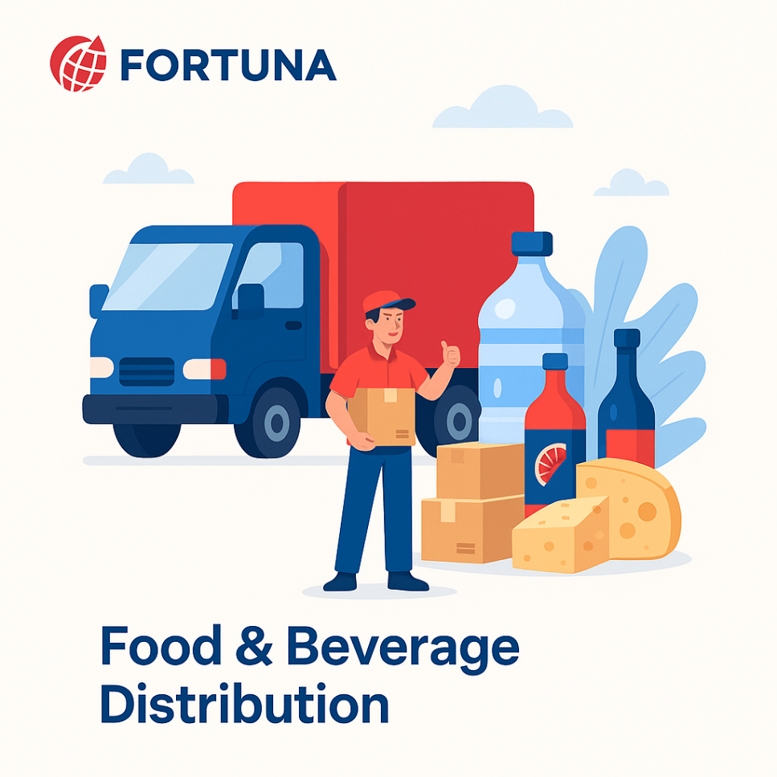
Freshness and safety are at the heart of Food & Beverage -supply chains. We enable end-to-end visibility with IoT-driven tracking, automated quality checks, and predictive demand planning—ensuring traceability from farm to fork.

Fashion & Retail Industry
•


With High seasonal demand & agile supply chain Planning, Fortuna will empowers retailers with faster replenishment & reduces stock outs

Pharma & Healthcare
•


Medical safety and regulatory compliance are non-negotiable. We provide automated solutions for cold chain logistics, product traceability, and compliance monitoring—ensuring life-saving medicines and healthcare products reach destinations safely and efficiently.

E-Commerce & Distributional Channels
•


In a fast-moving E-Com world, speed and efficiency are critical. Our platforms enable automated order management, demand forecasting, and last-mile delivery optimization—ensuring customers receive the right products, at the right time, every time.

🏛️ Corporate Identity

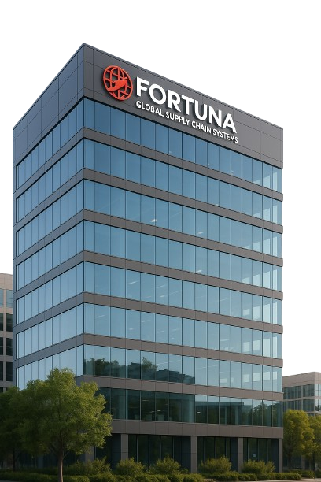
Headquarters: Visakhapatnam, Andhra Pradesh, India
Website: www.fortunaglobalsupplychain.com
Email: info@fortunaglobalsupplychain.com

